Understanding How Genes are Inherited via Meiosis and Fertilization

Introduction
1a. What is a gene?

1b. How does a child inherit one copy of each gene from each parent? Summarize what you already know.

2. Describe the processes that ensure that each cell in your body has a complete set of chromosomes with all the genes.

3. This flowchart summarizes how a child inherits one copy of each gene from each parent. During fertilization, a sperm unites with an egg to produce a zygote, which is a fertilized egg. Fill in the blanks in the flowchart.

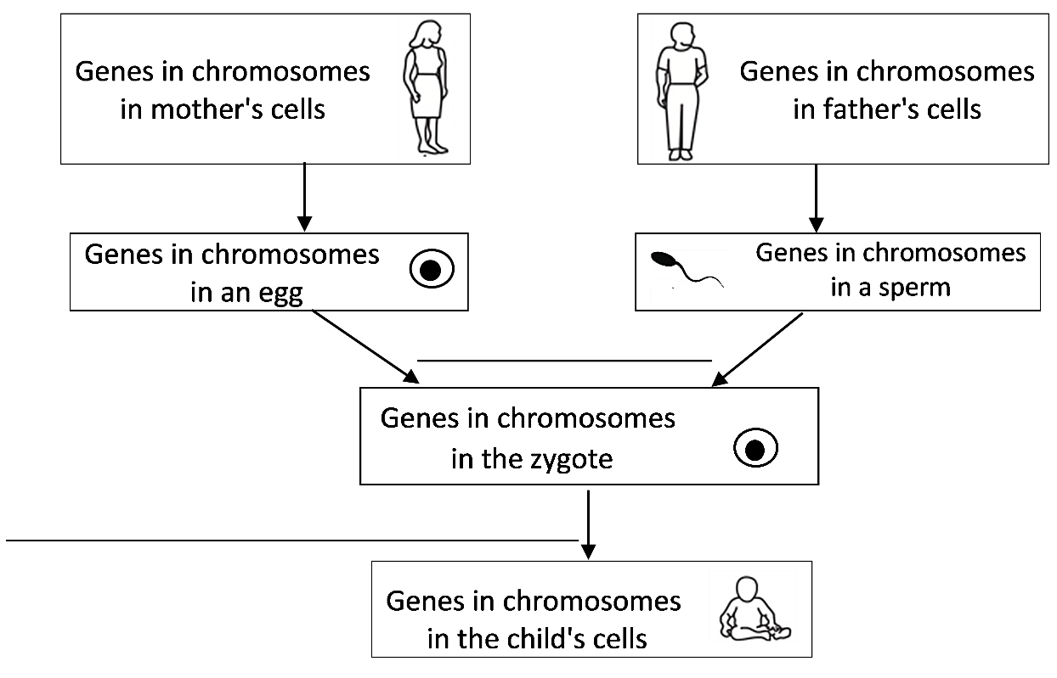
4. The zygote has all the chromosomes with all the genes that were in the egg and sperm. What problem would occur if eggs and sperm were produced by mitosis?

To understand the biological solution to the problem that would occur if eggs and sperm were made by mitosis, we need to think about pairs of homologous chromosomes. In a pair of homologous chromosomes, both chromosomes have the same genes in the same locations. However, each chromosome in the pair may have different versions of many of the genes.

- A diploid cell has pairs of homologous chromosomes. Almost all the cells in your body are diploid.  - A haploid cell has only one chromosome from each pair of homologous chromosomes. Eggs and sperm are haploid cells. | 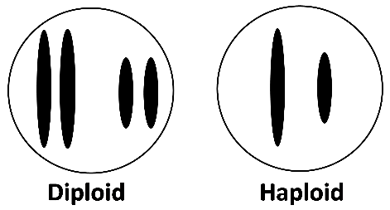

5a. Circle each pair of homologous chromosomes in the above figure.

5b. A haploid cell has ____________ as many chromosomes as a diploid cell.
(half / twice)
5c. The cells in your tongue, stomach and intestines are ________________ .
(diploid / haploid)

The type of cell division that produces haploid eggs and sperm from diploid cells is called meiosis. As a result of meiosis, each egg or sperm receives one chromosome from each pair of homologous chromosomes in the parent.
6a. Fill in each blank in this flowchart. The completed flowchart will summarize how a child inherits one copy of each gene from each parent.  6b. Write haploid next to any cell that is haploid.  6c. Circle a pair of homologous chromosomes in the zygote.  6d. Match each item in the first list with the best match from the second list.  Diploid cell → diploid cells ___  Diploid cell → haploid cells ___  Haploid cells → diploid cell ___  a. Fertilization b. Meiosis c. Mitosis | 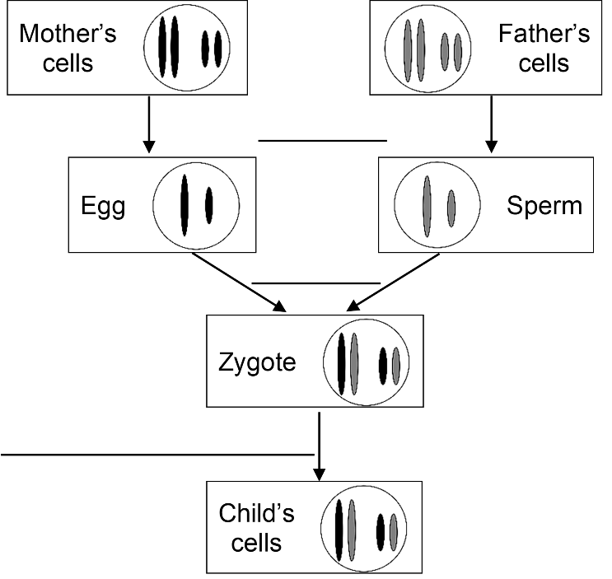

7. Use what you have learned to explain how each cell in a child gets one copy of each gene from his/her mother and another copy of each gene from his/her father. (Hints: You can use the flowchart in question 6 as an outline for your answer to this question. A complete answer will include these terms: meiosis, haploid, egg, sperm, pair of homologous chromosomes, gene, fertilizes or fertilization, diploid, zygote, DNA replication, mitosis.)

Three Human Genes

In later sections of this activity, you will follow these three human genes during meiosis.

Everyone has the same genes in the same chromosomes, but different people can have different versions of a gene. Different versions of the same gene are called alleles. Different alleles give the instructions for making different versions of a protein. This table gives an example.

Allele | → | Protein
A | → | Functional protein enzyme that can make melanin, a pigment molecule that gives color to human skin and hair
a | → | Nonfunctional protein enzyme that cannot make melanin

8. In the above table, circle each word or letter that represents a segment of a DNA molecule in a chromosome.

A genotype is the combination of alleles in each body cell. The phenotype describes the person’s characteristics. This table shows the genotypes and corresponding phenotypes for three human genes.

Genotype | → | Protein | → | Phenotype (characteristics)
AA or Aa | → | Enough functional enzyme to make melanin, the pigment molecule that gives skin and hair their color | → | Normal skin and hair color
aa | → | Nonfunctional enzyme that cannot make melanin | → | Very pale skin and hair color; albinism
HH or Hh | → | Enough normal hemoglobin to prevent sickle cell anemia | → | Normal red blood cells
hh | → | Sickle cell hemoglobin, which can cause red blood cells to become sickle shaped | → | Sickle shaped red blood cells can block blood flow in small blood vessels, causing pain and organ damage; fewer red blood cells; sickle cell anemia
II or Ii | → | Nonfunctional enzyme that cannot dispose of harmful molecules produced by the metabolism of alcohol | → | Discomfort and skin flush after drinking alcohol; alcohol intolerance
ii | → | Functional enzyme that disposes of harmful molecules produced by alcohol metabolism | → | Not alcohol intolerant

9a. Explain why each genotype in the above table has two letters.

9b. Explain why a person with the aa genotype has very pale skin and hair color. Include the words protein, enzyme and melanin in your explanation.

10. Danielle has the combined genotype AaHhIi. What is Danielle’s phenotype?

How Meiosis Makes Haploid Eggs and Sperm

Eggs and sperm are called gametes. The figure below shows how a diploid cell divides into haploid gametes. First, the DNA in the diploid cell is replicated and then two cell divisions produce four haploid gametes. The two cell divisions are called meiosis I and meiosis II.

11. Each paragraph below describes one step in meiosis. Draw an arrow from each paragraph to the matching part of the figure.  At the beginning of meiosis I, the two copies of the DNA in each chromosome are condensed into sister chromatids. The two homologous chromosomes are lined up next to each other.  During the meiosis I cell division, the two homologous chromosomes are separated into two daughter cells. These daughter cells are haploid since each daughter cell has only one chromosome from the pair of homologous chromosomes.  During meiosis II, the sister chromatids of each chromosome are separated. Meiosis II produces four haploid daughter cells that become gametes.  12a. The A and a alleles are only labeled on some of the chromosomes or chromatids. Use your understanding of DNA replication and meiosis to label the A or a alleles on the other chromosomes and chromatids. | 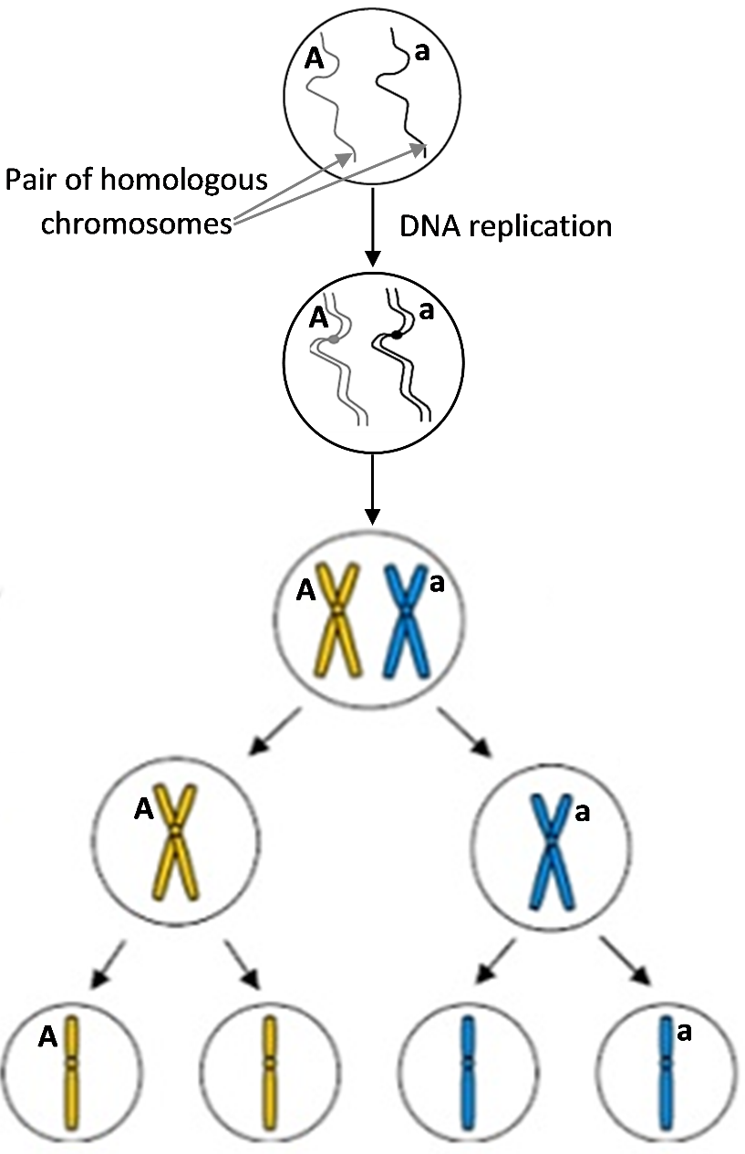

12b. For the labeled gene, there are ___ different types of haploid gametes.
(1/2/3)

13. To produce haploid gametes, DNA is replicated ___ time(s), followed by ___ cell division(s).
(0/1/2) (0/1/2)

14. To describe the characteristics of meiosis I, meiosis II, and mitosis, put a check for each characteristic that applies.

 | Meiosis I | Meiosis II | Mitosis
Separates pairs of homologous chromosomes
Separates sister chromatids
Produces genetically identical diploid cells
Produces genetically diverse haploid cells
Two additional processes contribute to the enormous genetic diversity of different gametes produced by the same person. The first is called crossing over. When a pair of homologous
chromosomes is lined up next to each other at the beginning of meiosis I, the two homologous chromosomes can exchange parts of their chromatids. This figure shows crossing over for a pair of homologous chromosomes. At the beginning of meiosis, one chromosome has the A and H alleles and the other chromosome has the a and h alleles.

15. Label the alleles for these genes on each chromatid of the chromosomes in the bottom row.

16. After meiosis separates the pair of homologous chromosomes and the sister chromatids, the gametes will have four different combinations of the alleles for these two genes. The combinations of alleles in the different

gametes will be _AH_ _______ _______ _______ .
The second process that contributes to the genetic diversity of eggs and sperm is only observed if there are two or more pairs of homologous chromosomes. The figure below shows that two pairs of homologous chromosomes can line up in two different ways at the beginning of meiosis I. This is called independent assortment, since each pair of homologous chromosomes lines up independently of how the other pair of homologous chromosomes lined up.

17. Complete this chart. Draw the missing chromosomes and label the alleles on each chromatid and chromosome.
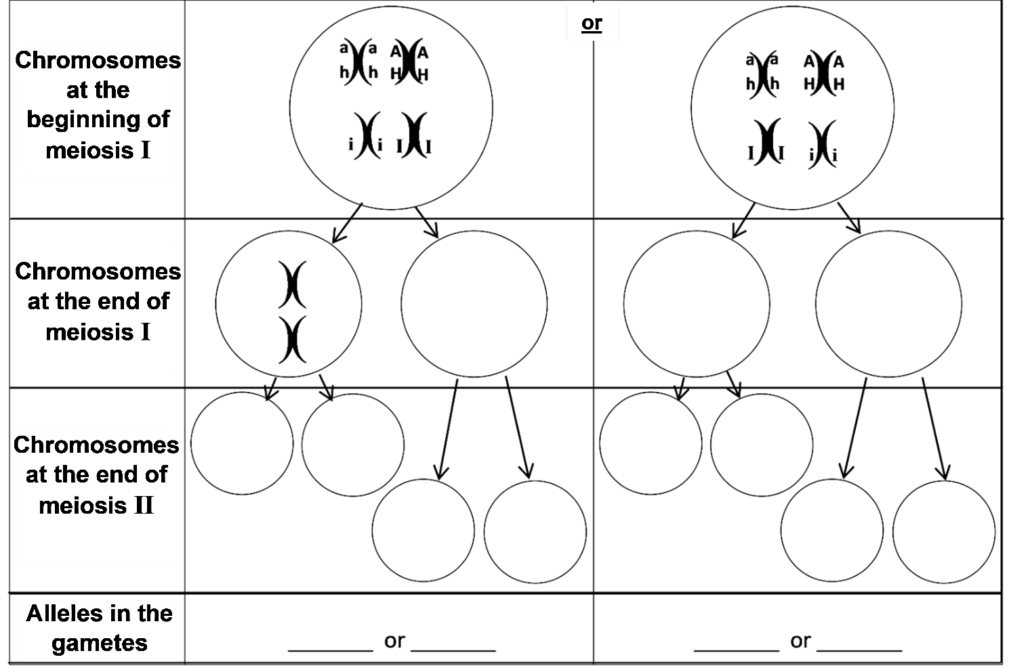
18. In question 17, you analyzed the outcomes of meiosis for a parent who has a pair of homologous chromosomes with the AH and ah alleles and another pair of homologous chromosomes with the I and i alleles. You saw that independent assortment resulted in gametes with four different combinations of these alleles. What additional process during meiosis could produce gametes with these four additional combinations of alleles – aHi, aHI, AhI and Ahi?

This analysis shows that meiosis can produce gametes with eight different combinations of the alleles for these three genes. Each human body cell has roughly 20,000 genes in 23 pairs of homologous chromosomes. Independent assortment of 23 pairs of homologous chromosomes can produce more than 8 million different combinations of chromosomes in different gametes produced by the same person! Crossing over results in an even greater number of different combinations of alleles in these gametes.

To review how meiosis produces genetically diverse haploid gametes, view “Meiosis” (https://www.youtube.com/watch?v=D1_-mQS_FZ0).

Genes are inherited via meiosis and fertilization.
To learn how meiosis and fertilization determine the genetic makeup of a child, you will analyze inheritance for two parents who both have the Aa genotype. This flowchart shows how these parents could have a child with the Aa genotype. (To analyze inheritance via meiosis and fertilization, we will follow the alleles of one gene only.)

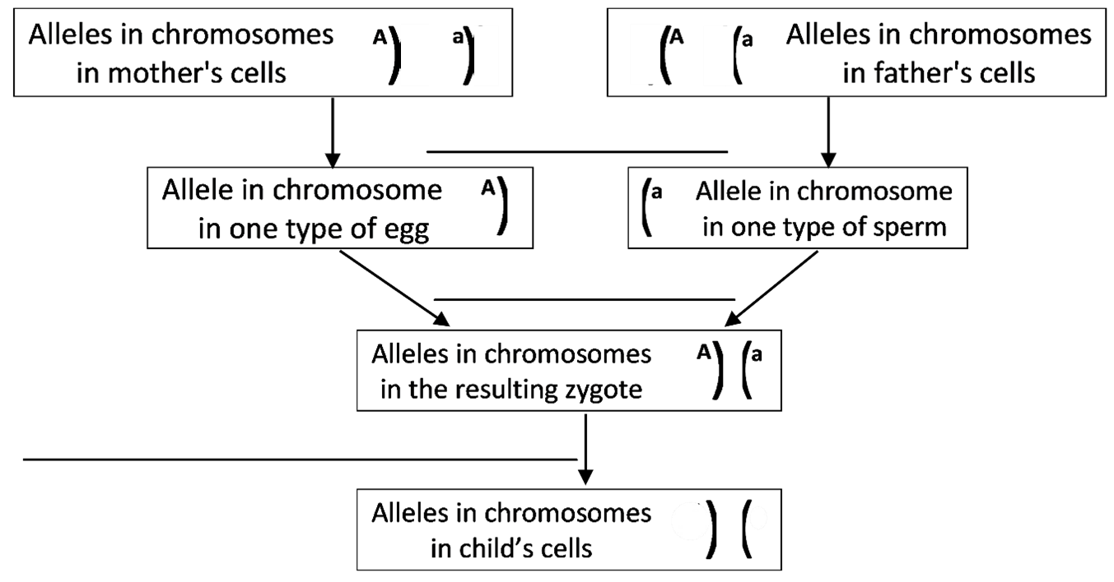
19a. Fill in the blanks in this flowchart.

19b. Label the alleles in the child’s cells.

19c. Explain how you know what these alleles are.

19d. Do you think that this is the only possible outcome of meiosis and fertilization for two Aa parents? yes ___ no ___

19e. Explain why or why not.

This chart shows the possible outcomes of meiosis and fertilization for two Aa parents. The two possible outcomes of meiosis are shown for each parent (near the top and on the left). The possible outcomes of fertilization are shown in the boxes labeled zygote.

20a. Circle the part of this chart that shows how meiosis and fertilization can produce a zygote with the genetic makeup AA.

20b. Describe the two different ways that an Aa zygote can be produced.

Biologists use a similar chart to analyze inheritance However, biologists omit much of the detail and use a simplified version called a Punnett Square. |  | A | a
 | A | AA | Aa
 | a | Aa | aa

21. In the Punnett square:
- Write G next to each letter that represents the genetic makeup of a gamete.
- Write Z next to each pair of letters that represents the genetic makeup of a zygote.

22a. In the table below, circle the genotype and phenotype of the mother and father.

Genotype | → | Protein | → | Phenotype (characteristics)
AA or Aa | → | Enough functional enzyme to make melanin in skin and hair | → | Normal skin and hair color
aa | → | Nonfunctional enzyme that cannot make melanin | → | Very pale skin and hair color; albinism

22b. In the Punnett square, circle the genotype of each zygote that would develop into a person with the same phenotype as his or her parents.

22c. Use an * to mark the zygote that would develop into a person with a different phenotype that neither parent has.

23a. Explain why children often have the same phenotype as their parents.

23b. Explain how a child can have albinism when neither parent has albinism.

You have already learned that each person has thousands of genes in 23 pairs of homologous chromosomes, so independent assortment and crossing over during meiosis can produce many millions of different combinations of alleles in his/her gametes. If each different type of egg from one mother could be fertilized by each different type of sperm from one father, this would produce zygotes with trillions of different combinations of alleles.

24. Explain why no two siblings inherit exactly the same combination of alleles from their parents (except for identical twins who both developed from the same zygote). A complete answer will include the following terms:
genes, homologous chromosomes, alleles, crossing over, independent assortment, meiosis,
gametes, millions, egg, sperm, fertilized or fertilization, zygote, trillions.

Sexual vs. Asexual Reproduction

Thus far, we have been discussing sexual reproduction in humans. Asexual reproduction involves only mitosis, without meiosis and fertilization. Asexual reproduction occurs in many
types of plants and some types of animals.  This figure shows one type of asexual reproduction. Repeated cell cycles with DNA replication, mitosis and cytokinesis produce the cells that form a bud. Then, the bud breaks off to form a daughter hydra. | 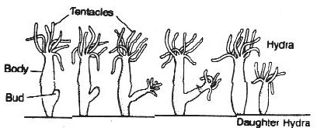  A hydra is an animal that lives in the water and uses its  tentacles to catch food.

25. Are there any genetic differences between the mother hydra and the daughter hydra? Explain your reasoning.

26a. What would be the advantage of asexual reproduction for an organism that lives in a stable environment that does not change?

26b. What would be the advantage of sexual reproduction for an organism that grows in a variable environment that often changes?

by Drs. Ingrid Waldron, Jennifer Doherty, R. Scott Poethig, and Lori Spindler, Department of Biology, University of Pennsylvania, © 2022; this Student Handout and Teacher Notes with background information and instructional suggestions are available at https://serendipstudio.org/exchange/bioactivities/meiosisRR

